Chapter 17, Problem 23.

Using Fig. 17.61, design a problem to help other students better understand finding the Fourier series of a periodic wave shape.
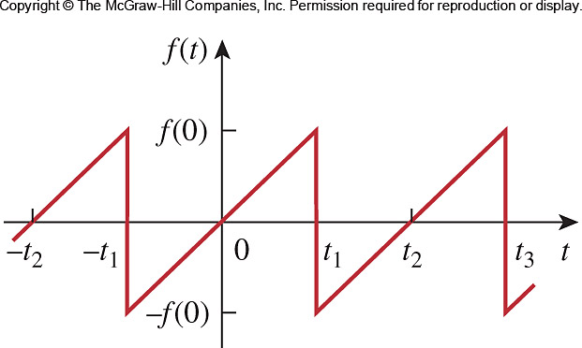

Figure 17.61
For Prob. 17.23.

